EC2 is created with SG – all traffic allowed
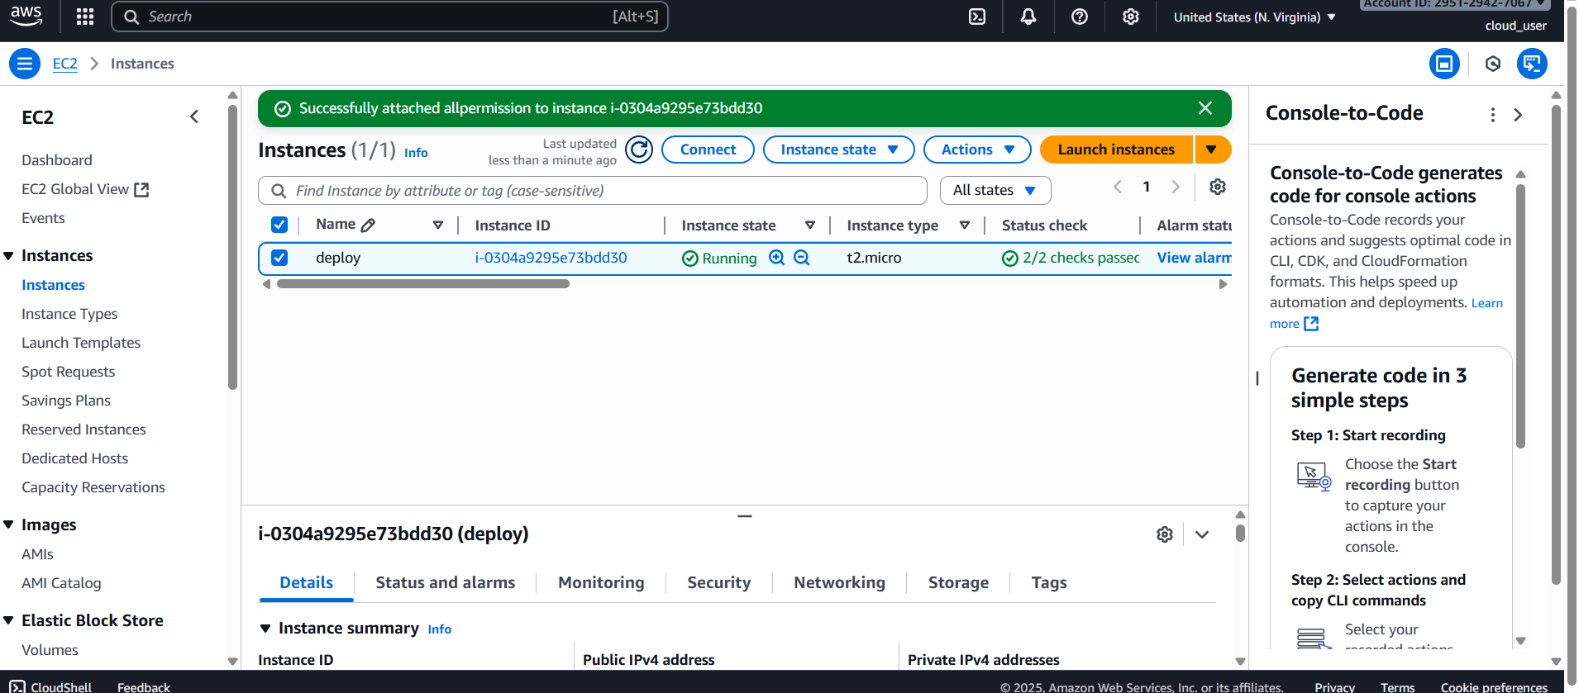
IAM role with admin access is created and attached to server
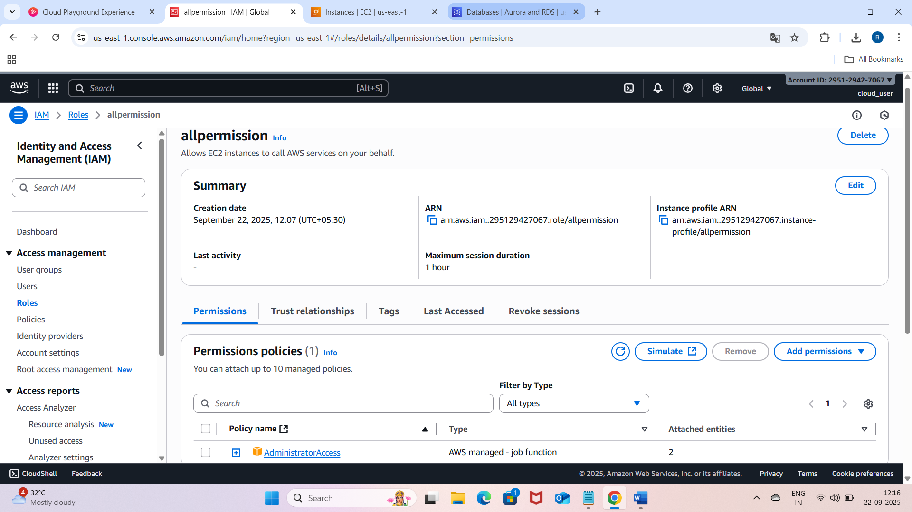
Database is created
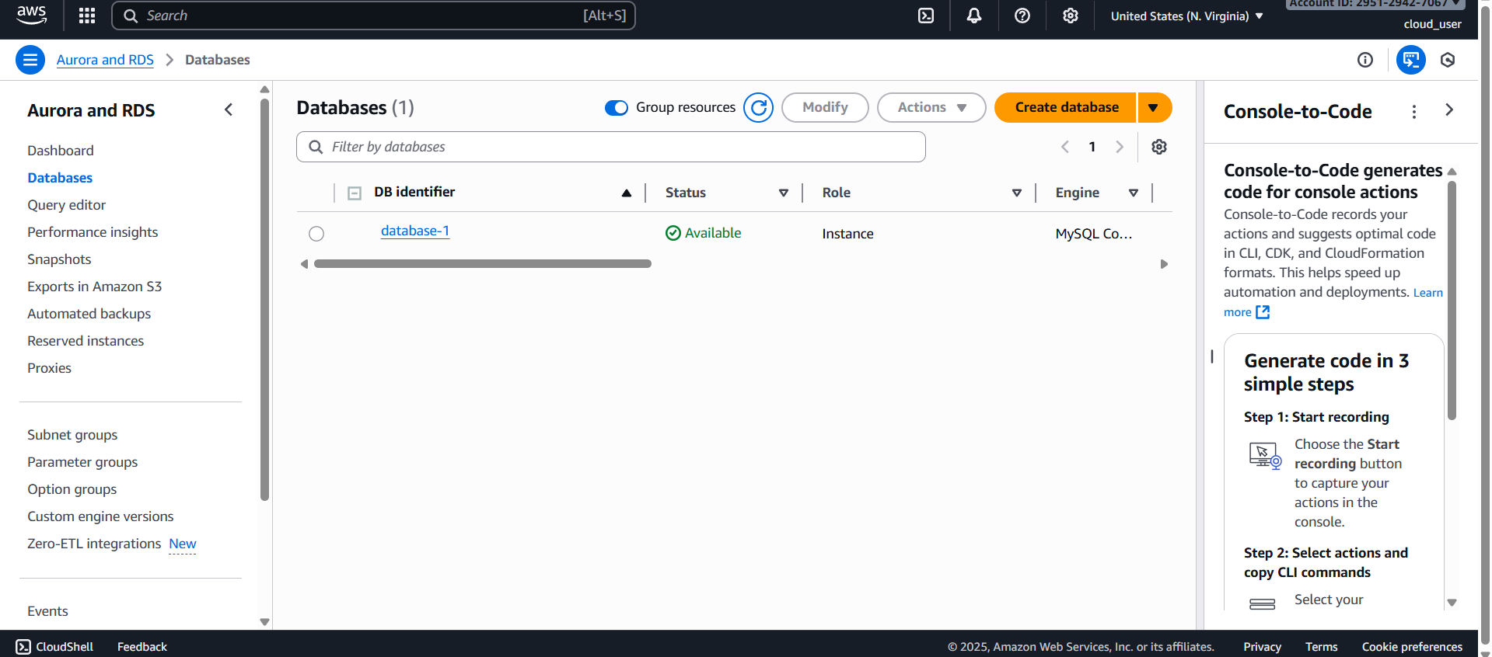
Connected to server , installed all dependencies and connected to DB. Created dev DB and table.
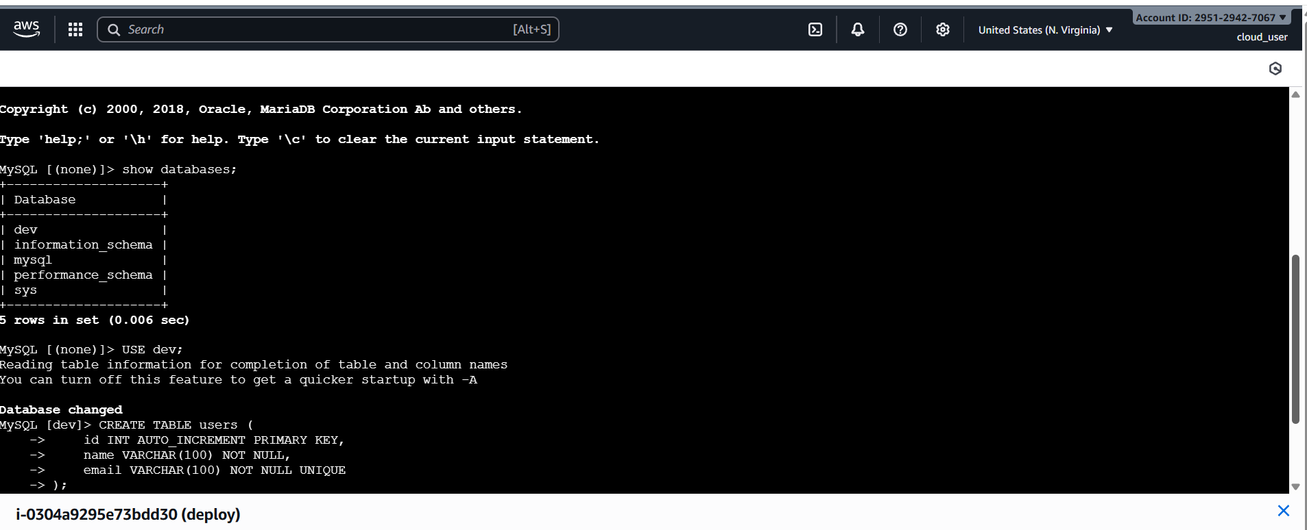
Inserted records in privateDB using POST method and displayed content using GET
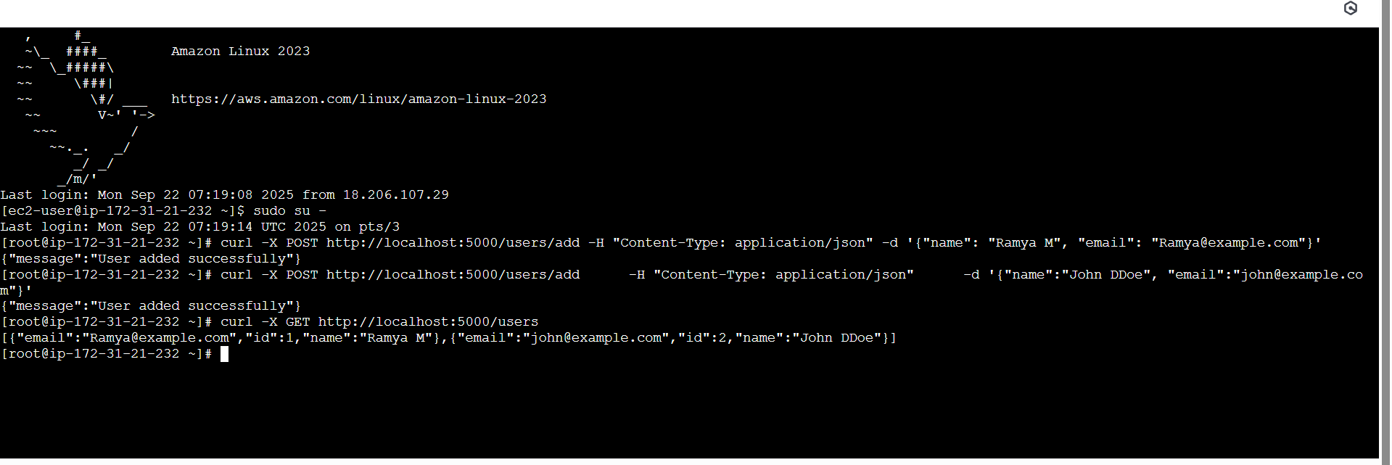
Killed python
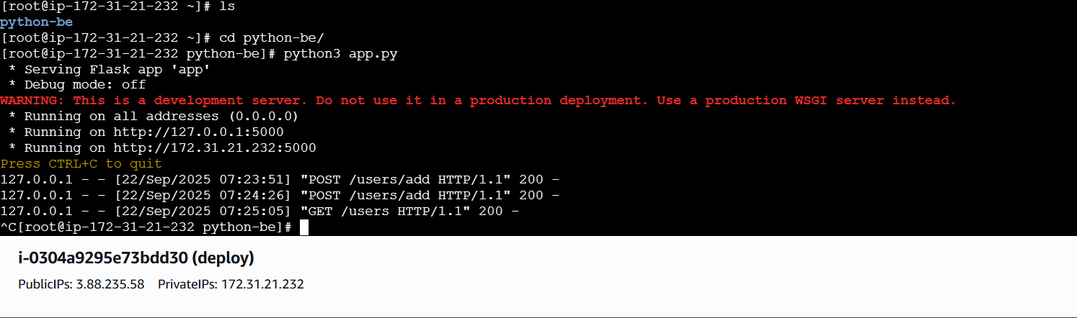
After kill able to check DB
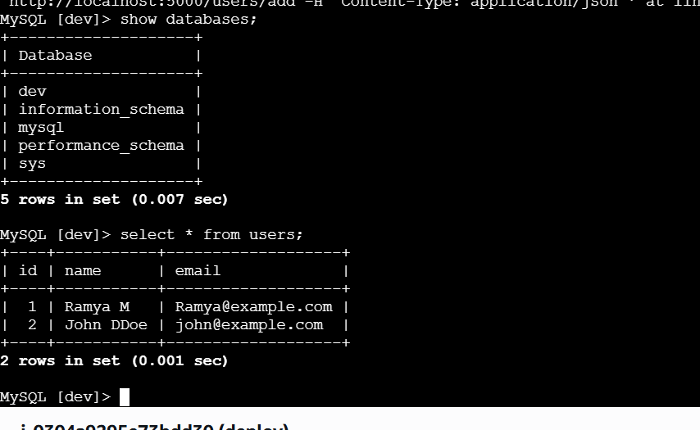
But not able to post / add new records after python is killed
